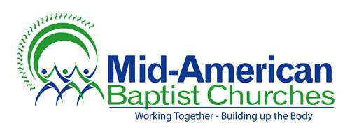
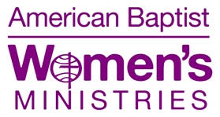

Mid-American Baptist Women Scholarship Application

Please note that the application must be typed or neatly handwritten with attached transcripts and a Statement of Faith. Please include church activities and responsibilities that you have participated in. Applications must be postmarked by May 15th.

Please send application and the additional required documents to:
Dianne Van Gorder
1621 Williston Ave
Waterloo, Iowa 50702

Name___________________________________________________________________________

Address_________________________________________________________________________

Email address____________________________________________________________________

Cell phone number________________________________________________________________

Parents name(s)__________________________________________________________________

Home Church (include membership date)_____________________________________________

________________________________________________________________________________

School you are currently attending __________________________________________________

Expected Graduation date__________________________________________________________

College Plans (include major area of study) ___________________________________________
________________________________________________________________________________

Other family members currently enrolled in college ____________________________________
________________________________________________________________________________

Is this the year that you are applying for this scholarship?_______________________________

If you have questions please contact Dianne at 319-234-6970

